Introduction: Visual Studio Community is a popular integrated development environment (IDE) that provides comprehensive tools and features for C++ development. For this project I used Visual Studio version 17.5.5. The steps for installing the IDE and setting up C++ for development are as the following:

Procedure:

1. Download and Install Visual Studio Community:
   * Visit the official Visual Studio website (visualstudio.microsoft.com).
   * Locate the Community edition and download the installer.
   * Run the installer and follow the on-screen instructions.
   * During installation, select the C++ workload to ensure the necessary components are installed.
   * Launch Visual Studio Community:
   * After installation, locate and launch Visual Studio Community.
2. Create a New C++ Project:
   * From the start screen, click on "Create a new project" or go to "File" > "New" > "Project" from the menu.
   * In the project template selection window, choose "Installed" > "Templates" > "Visual C++".
   * Select Empty Project.
3. Configure Project Settings:
   * Set Project name as Ball.
   * Ensure the "Create directory for solution" option is checked.
4. Write C++ Code:
   * Add new file main.cpp to the project.
   * Begin writing your C++ code.
5. Build and Run the Project:
   * Press Ctrl+Shift+B to build the project.
   * If the build process completes without errors, you can run the program.
   * Press Ctrl+F5 or select "Debug" > "Start Without Debugging" from the menu to run the program.

After having done these we should start writing the code for the ball project. Since the project is graphical and needs to import an image and create a window also capture keypress and mouse motion, I chose to use the SDL library for its simplicity. As to setup this library for this project there are a number of steps:

Go to [https://github.com/libsdl-org/SDL/releases/tag/release-2.26.5 for downloading the 2.26.5](https://github.com/libsdl-org/SDL/releases/tag/release-2.26.5%20for%20downloading%20the%202.26.5) version of the SDL2 library.

Download the file [SDL2-devel-2.26.5-VC.zip](https://github.com/libsdl-org/SDL/releases/download/release-2.26.5/SDL2-devel-2.26.5-VC.zip).

Extract the file into a folder which will be linked to the project later. In this project it is extracted to CPP_Project/libs.

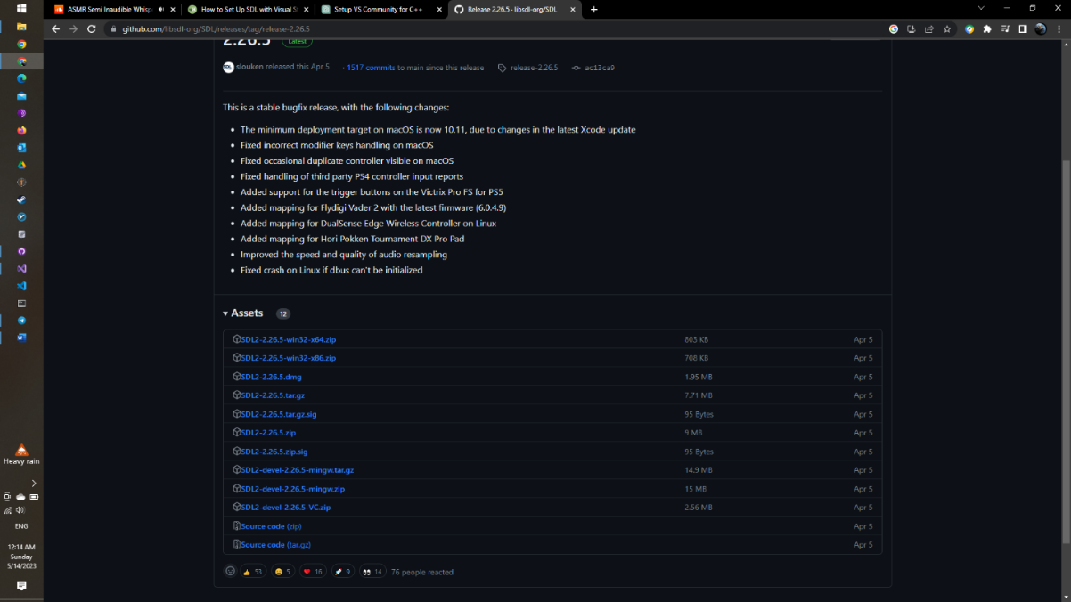

Project's Property Pages. Go to "Solution Explorer" > right click on the name of your project Ball > select "Properties". In Ball Property Pages wizard,

1. Main menu:

* In Configuration entry select Active (Debug) > in Platform: entry, select x64 > Click Configuration manager...
* In Configuration Manager wizard, in Active solution platform: select x64
* In Platform entry, x64 is selected automatically.
* Click Close

2. Additional Include Directories: See below images.

* In Ball Property Pages window double click C/C++ > click General > Additional Include Directories > down arrow at the end of the field > click <Edit...>.
* Copy include folder under SDL2-2.26.5 directory and paste in Additional Include Directories wizard's upper-most text field.
* 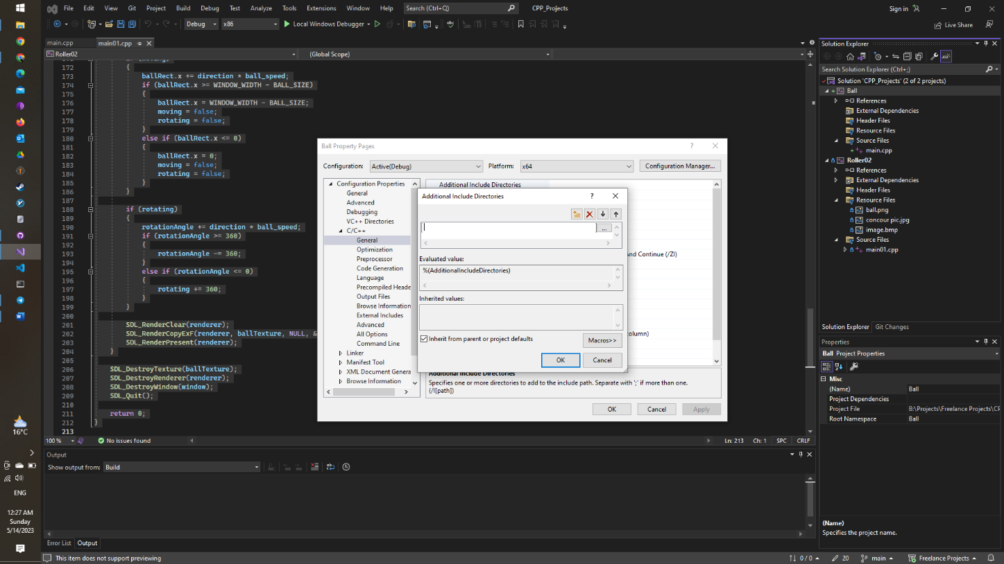In Additional Include Directories wizard click OK.

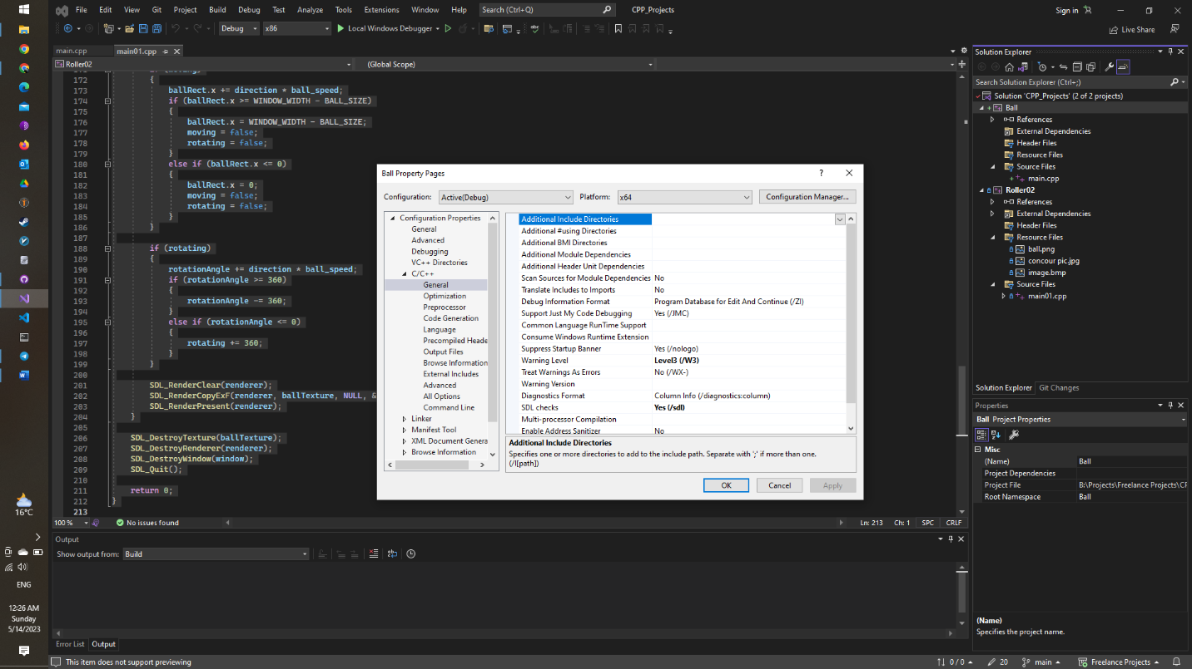

3. Additional Library Directories:

* In the "Ball Property Pages" wizard, open Linker (see below image) > click General > Additional Library Directories > down arrow at the end of the field > click <Edit... >.
* Copy  lib\x64 directory under SDL2 folder and paste in Additional Library Directories wizard's upper-most text field.
* Click OK in Additional Library Directories wizard.

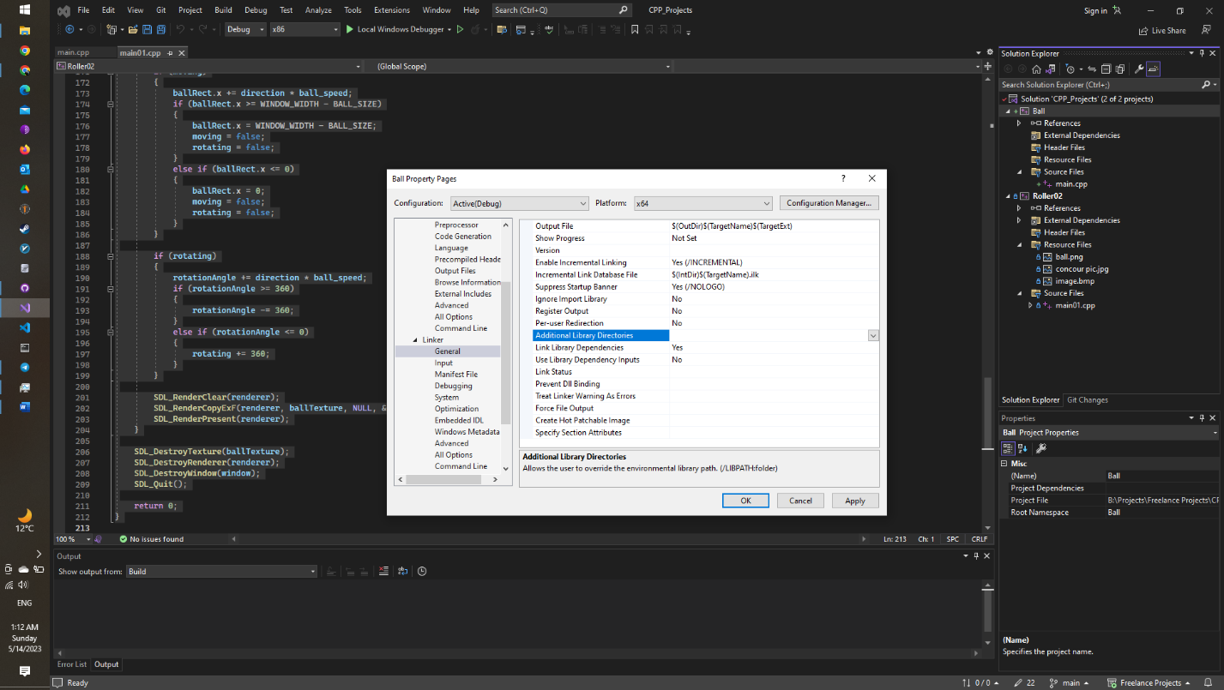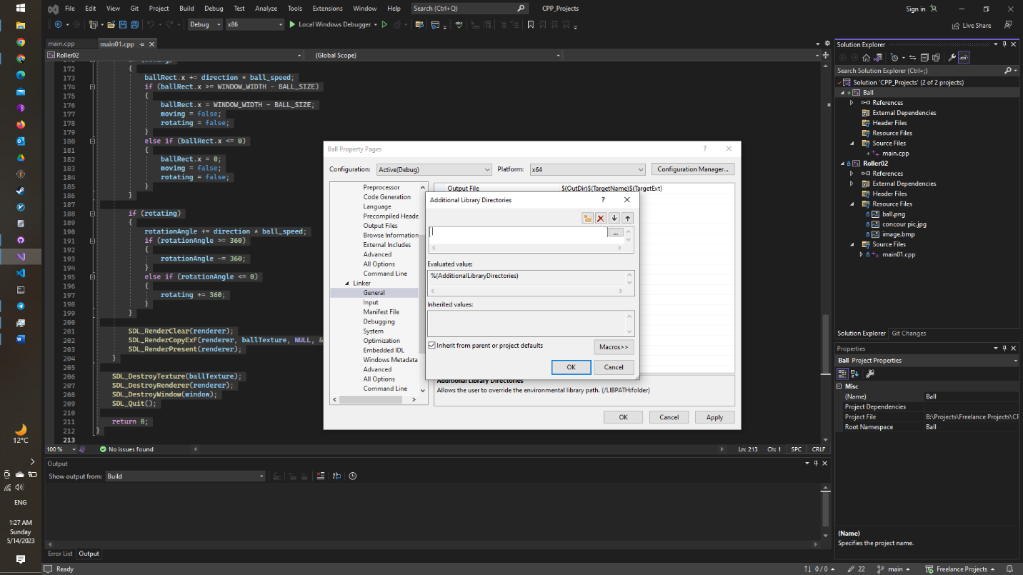

4. Additional Dependencies:

* In "Linker" drop-down menu (see below image), click "Input" > the "Additional Dependencies" entry > down arrow at the right of the field > "Edit".
* Copy “opengl32.lib; SDL2.lib;SDL2main.lib” and paste in top-most text box in "Additional Dependencies" wizard.
* 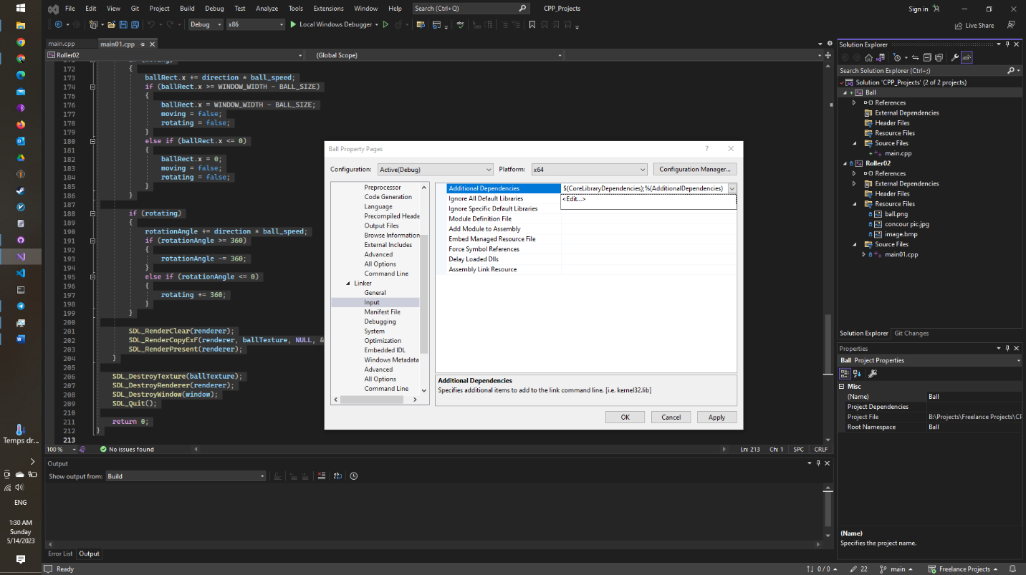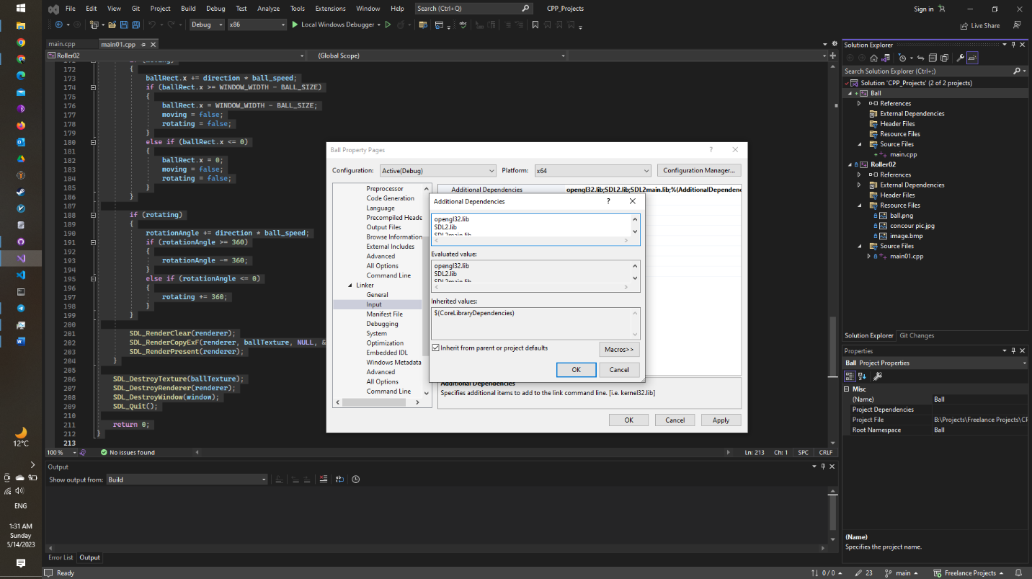In "Additional Dependencies" wizard click OK.

5. System:

* In Linker drop-down menu (see below image), click System > SubSystem > down arrow at the end of the field > select Console (/SUBSYSTEM:CONSOLE).
* 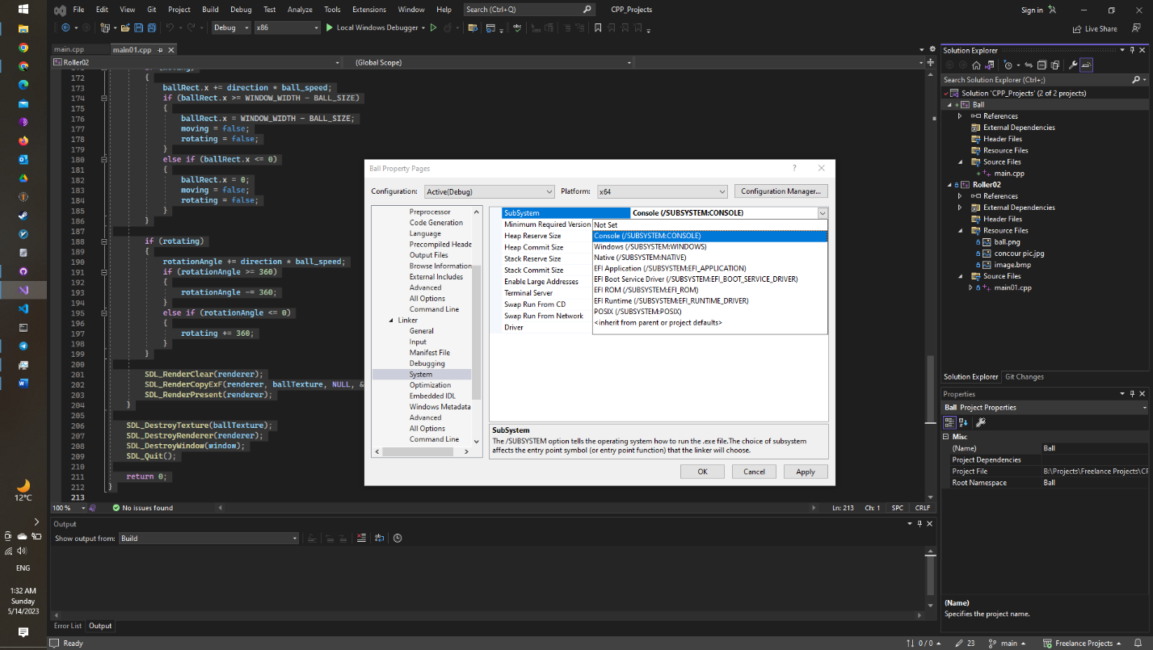Click Apply and then OK in "Project's Property Pages" wizard.

Add dll file path (address) to "System Variables":

* In Windows search box on the taskbar (bottom left of the screen) type envir > hit ↵ Enter. "System Properties" wizard is thrown.
* Select the "Advanced" tab from the top bar > click Environment Variables.... "Environment Variables" wizard is thrown.
* Double click the "Path" (or "PATH") Variable in the "System Variables" section. "Edit environment variable" wizard is thrown.
* Copy lib\x64 directory under SDL2 folder > click New > Paste.
* Click OK in all 3 wizards.
* Close Visual Studio > in thrown wizard "Save changes to the following items?" click Save.
* Restart your PC > open Visual Studio. In "Open recent" list, click "SDLx64-0.sln", the first one. Now your project is open ready for test.

Now the configuration and library installation for the project has finished and we can code the requested program.